

**Your Company Name**

Network Design Proposal

for

Client Company Name

Prepared on 10/12/2022

# Table of Contents

**Section Page**

Introduction 1

Executive Summary 2

Business Profile 3

Proposed Logical Network Layout 4

Proposed Physical Network Layout 6

Cost Estimates 8

Additional Comments 9

Appendix A – Current Office Layout 10

# Introduction

This document is full of awesomeness and many good things.

This section will set the stage for the awesomeness to come.

# Executive Summary

Client Company Name has asked Your Company Name to bid on an upcoming network buildout at their new head office. Our proposal includes 228 pairs of tin cans and 6000 feet of category 17 twisted twine to interconnect them, as well as a few pigeons for stringless communications. Total hardware costs are estimated to be $250, with a buffer of $300 in case the lower-cost cat 17 string is not available. Annual upkeep of the pigeons will be $200, plus the time of a co-op student. Installation labour costs for this job are not a factor as Your Company Name will use a government program to employ co-op and newly graduated students, therefore labour costs will be covered. Internet access will cost a total of $7500 in year one, and $4800 on an annual basis.

In summary, first-year costs will be $8050. Total annual upkeep should be budgeted at $5000 to include low-cost co-op students for maintenance activities, the pigeons, monthly costs for Internet access, the replacement of rusting tin cans and to accommodate changing office layouts and, of course, new runs of string.

# Business Profile

Client Company Name, an importer of high-end shoelaces, has grown steadily over the last 15 years and now totals over 300 employees who are moving to a new set of offices in a five-floor office building near Hamilton, Ontario.

Client Company Name has determined that the following departments will be located in the new offices:

|  |  |
| --- | --- |
| Department | Size |
| Executive Staff | 37 |
| Buyers | 13 |
| Sellers | 15 |
| IT | 10 |
| HR | 10 |
| Shoelace lacers | 150 |
| Shoelace unlacers | 75 |

The business has identified the following major servers/services:

* E-mail
* Internet use
* **S**hoelace **A**cquisition and **S**ales **Sy**stem (SASSy) – this is a large, non-virtualized database application system
* **A**utomatic **W**izard for **E**nterprise **S**hoelace **O**rdering and **M**anufacture **E**nablement (AWESOME) – this is a second, non-virtualized database application server
* Approximately 20 virtualized application servers, such as **E**mployee **S**elf-**S**ervice (ESS), **C**ustomer **R**elationship **M**anagement (CRM), **E**nterprise **R**esource **P**lanning (ERP), etc.
* A collection of file servers, each hosting about 150 employees
* A physical server hosting corporate VOIP and IM services
* A physical server hosting Videoconferencing services

# Proposed Logical Network Layout

The following drawings illustrate the proposed logical network for Client Company Name’s new offices. It provides a high-level view of the interconnection between workers and their IT infrastructure. It includes the number of employees per department (as supplied by Client Company Name) and the resulting bandwidth requirements, and it shows the expected traffic to the Internet and from the end users to the core.



# Proposed Physical Network Layout

The following drawings illustrate the proposed physical network layout for Client Company Name’s new offices. They detail the major cable runs and locations of key IT infrastructure.

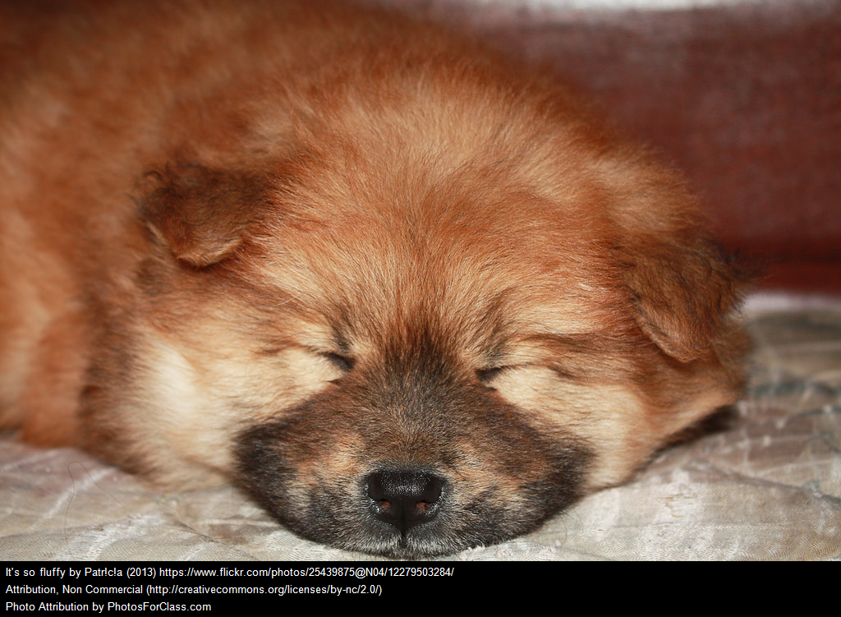



# Cost Estimates

As Client Company Name will be moving into new offices which have suitable wiring closets and plenty of space to run cable, this proposal focuses on hardware and recurring costs to build out the new head office LAN.

Buildout and recurring costs have been estimated as follows:

|  |  |  |  |  |  |  |  |
| --- | --- | --- | --- | --- | --- | --- | --- |
| **Item** | **Quantity** | **Purchase Cost (each)** | **Monthly Costs** | **Annual Support Costs (each)** | **Acquisition Cost** | **Total Yearly Costs** | **Notes** |
| Internet Connection | 1 | 2,700.00 | 400.00 |  | 7,500.00 | 4,800.00 | Includes termination hardware and five static IP external addresses |
| Tin Cans (pairs) | 228 | 0.22 |  | 0.02 | 56.68 | 5.67 | Soup sized |
| Category 17 twine | 2964 | 0.06 |  | 0.01 | 200.96 | 20.10 | Brown string, of course |
| Pigeons | 5 | 5.00 |  | 15.00 | 28.25 | 84.75 | Pre-trained |
| Pigeon perches | 5 | 4.00 |  |  | 22.60 |  | All pigeons need perches |
| Pigeon food | 5 |  | 10.00 |  |  | 135.60 | No stale bread - all seeds |
| Buffer |  |  |  |  | 313.35 |  | An allowance for unexpected issues |

Sales tax has been included in the above costs.

Total one-time costs are $8,121.84 (including a $313.35 allowance for unexpected issues) with total yearly recurring costs of $5,046.12.

# Additional Comments

This document is clearly full of nonsense. Your document should include valid content, appropriate support images and cost calculations. The wording used in this document does not need to be copied as-is – in fact, it should be changed to reflect your own findings and situation

If you need clarification on the process, document or other aspect of this assignment you should contact your professor as soon as possible.

Good luck!

# Appendix A – Current Office Layout

The unoccupied offices are currently configured as follows:



